Adrian Grimm

Week 6

Advanced Queries Lab

1.

SELECT DISTINCT c.CompanyName

FROM Customers AS c

JOIN (

SELECT CustomerID

FROM Orders AS o

JOIN [Order Details] AS od

ON o.OrderID = od.OrderID

WHERE od.Discount > .2) AS odd

ON c.CustomerID = odd.CustomerID;

My query returned 38 rows.

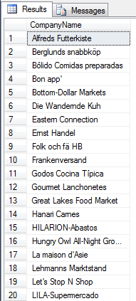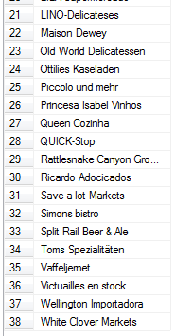

2.

SELECT t.title AS 'Book Title'

FROM titles t

WHERE NOT EXISTS (

SELECT title_id

FROM sales s

WHERE t.title_id = s.title_id)

ORDER BY t.PubDate;

